In CSS, a color can be specified by using a predefined color name:

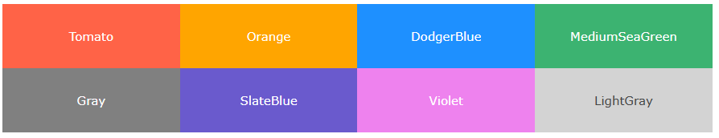

**CSS Background Color**

You can set the background color for HTML elements:

**<html>**

**<body>**

**<h1 style="background-color:DodgerBlue;">Hello World</h1>**

**<p style="background-color:Tomato;">**

**Lorem ipsum dolor sit amet, consectetuer adipiscing elit, sed diam nonummy nibh euismod tincidunt ut laoreet dolore magna aliquam erat volutpat.**

**Ut wisi enim ad minim veniam, quis nostrud exerci tation ullamcorper suscipit lobortis nisl ut aliquip ex ea commodo consequat.**

**</p>**

**</body>**

**</html>**

**CSS Text Color**

You can set the color of text:

**<html>**

**<body>**

**<h3 style="color:Tomato;">Hello World</h3>**

**<p style="color:DodgerBlue;">Lorem ipsum dolor sit amet, consectetuer adipiscing elit, sed diam nonummy nibh euismod tincidunt ut laoreet dolore magna aliquam erat volutpat.</p>**

**<p style="color:MediumSeaGreen;">Ut wisi enim ad minim veniam, quis nostrud exerci tation ullamcorper suscipit lobortis nisl ut aliquip ex ea commodo consequat.</p>**

**</body>**

**</html>**

**CSS Border Color**

You can set the color of borders:

**<html>**

**<body>**

**<h1 style="border: 2px solid Tomato;">Hello World</h1>**

**<h1 style="border: 2px solid DodgerBlue;">Hello World</h1>**

**<h1 style="border: 2px solid Violet;">Hello World</h1>**

**</body>**

**</html>**

**CSS Color Values**

In CSS, colors can also be specified using RGB values, HEX values.



**Example :**

**<h1 style="background-color:rgb(255, 99, 71);">...</h1>  
 <h1 style="background-color:#ff6347;">...</h1>**